# Validation of PDD-stitching in BistroMath

Theo van Soest, 17/7/2015

**Materials**On August, 11th a selection of PDD’s was measured in a BluePhantom 2 water tank.

|  |  |  |  |  |
| --- | --- | --- | --- | --- |
| nr | type | gantry | Field | SSD |
| 1 | complete | 0 | 10x10 | 100 |
| 2 | upper part | 0 | 10x10 | 100 |
| 3 | lower part | 0 | 12.5x12.5 | 80 |
| 4 | partial, shifted, 15 mm PMMA | 90 | 14.8x14.8 | 67.7 |
| 5 | partial, shifted, 15 mm PMMA | 90 | 10x10 | 67.7 |

The aim is to reconstruct a complete PDD at SSD 100 in BistroMath. Version 2.80, build 443 was used. In this build a separate shift value for PDD’s can be given. The current version takes the part with the highest SSD as target and converts the other part to this distance with a Mayneord correction before merging. The scatter conditions were held constant by maintaining the same field size at the surface.

**Results**  
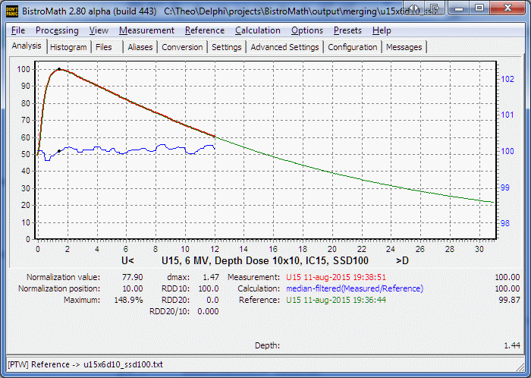

Scan nr. 1 was loaded as temporary reference. The partial repeated scan (nr. 2) is identical within the noise limits to the reference as is shown by the ratio of measurement and reference. Note that this is a division of local values and therefore is a *relative* error. The measurement was set as Source for merging.

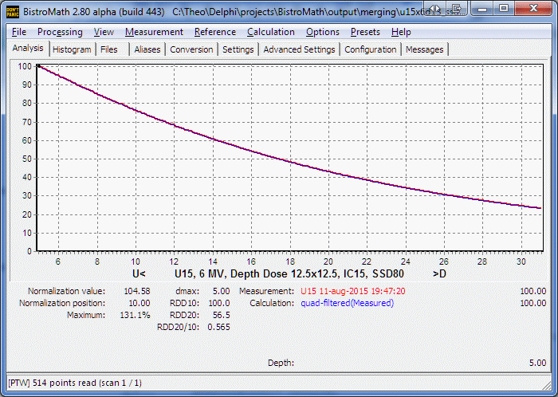

Scan nr. 3 at SSD 80 before merging.

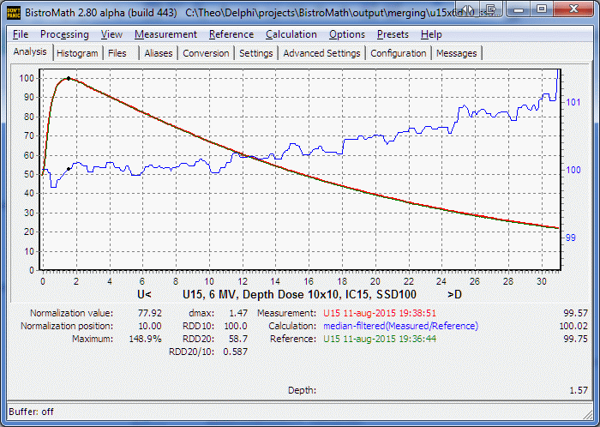

Merging of scan 2 and 3. The relative error at 30 cm is 1% of the local value, about 0.2% of Dmax.

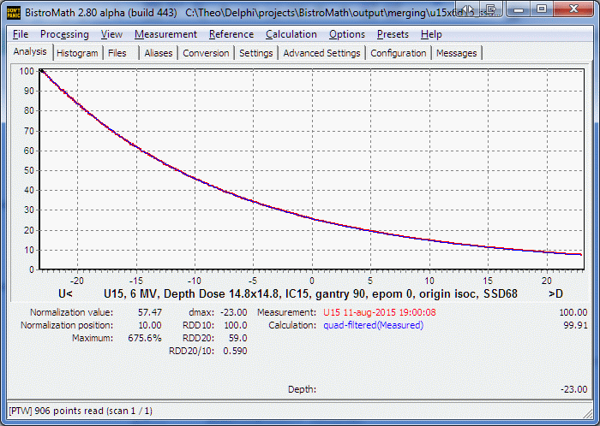

Scan nr. 4 at gantry angle 90. The origin is set at isoc. The SSD at the outside of the tank was 67.7 cm.



After merging, despite the wall of the tank, the error is only 1% at 30 cm when a 14.8x14.8 field is used.

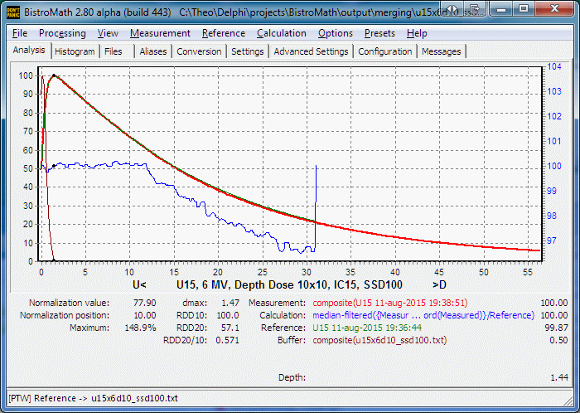

When for the lower part at SSD 67.7 a 10x10 field is used, the result is seriously degraded.

**Discussion and conclusions**  
The Mayneord correction, combined with constant field size at the surface produces acceptable results. The error is well within the uncertainty limits that can be expected from a calculated depth dose in a modern treatment planning system.  
As is shown in the last figure, the amount of scatter is relevant on all depths. The results suggest that keeping a constant field size at the surface is slightly overcompensating the introduced error. Might it be possible to tweak this rule a bit? This can be investigated by measuring a PDD for a series of field sizes.